**APP LOCKER**

**A Mini-Project Report**

**Under**

**Implementation Of Technology**

***Submitted by***

**E054 – Kartik Prakash**

**E056 – Aishwarya Rao**

**E058 – Pranav Toggi**

**E072 – Priyanka Purohit**

***Under The Guidance Of***

**Poonam Gupta**

***in partial fulfillment for the award of the degree***

***of***

**B. Tech**

**in**

**Computer engineering**

**at**



**Mukesh Patel School of Management & Engineering**

**April 2016**

**CERTIFICATE**

This is to certify that the project entitled App Locker is the bonafide work carried out by **Kartik Prakash, Aishwarya Rao, Pranav Toggi, PriyankaPurohit**B.Tech (Computer Engineering), MPSTME (NMIMS), Mumbai, during the fourth semester of the academic year 2015-2016, in fulfillment of the requirements for the award of the Degree of Bachelors of Technology as per the norms prescribed by NMIMS. The project work has been assessed and found to be satisfactory.

_______________

Poonam Gupta Internal Mentor

________________________ __________________

Examiner 1 Examiner 2

________________________

Dean

Dr. Sharad Y. Mhaiskar

**DECLARATION**

We, **Kartik Prakash, Aishwarya Rao, Pranav Toggi, PriyankaPurohit** B.Tech (Computer Engineering), semester- IV, understand that plagiarism is defined as anyone or combination of the following:

1. Un-credited verbatim copying of individual sentences, paragraphs or illustration (such as graphs, diagrams, etc.) from any source, published or unpublished, including the internet.

2. Un-credited improper paraphrasing of pages paragraphs (changing a few words phrases, or rearranging the original sentence order)

3. Credited verbatim copying of a major portion of a paper (or thesis chapter) without clear delineation of who did wrote what.

4. We have made sure that all the ideas, expressions, graphs, diagrams, etc., that are not a result of our work, are properly credited. Long phrases or sentences that had to be used verbatim from published literature have been clearly identified using quotation marks.

5. We affirm that no portion of my work can be considered as plagiarism and we take full responsibility if such a complaint occurs. We understand fully well that the guide of the seminar/ seminar report may not be in a position to check for the possibility of such incidences of plagiarism in this body of work.

Signature of the Students:

___________ ____________ ___________ ____________

Name:Kartik Prakash, Aishwarya Rao, Pranav Toggi, PriyankaPurohit

Roll No.E054E056E058E072

Place: Mumbai

Date: April 2016

**Acknowledgements**

We would like to thank our mentor, teacher and guide Miss Poonam Gupta for guiding us in this subject in which we had no prior knowledge. Whenever stuck, we did refer to helpful online forums and tutorial websites so we would like to thank them for providing valuable debugging information at crucial times. Last but definitely we would like to thank the already existing app locks from which we managed to pull out ideas and features to incorporate within our created app.

**Table of contents**

**CHAPTER. NO.       TITLE                                                                                    PAGENO.**

             Abstract                             I

             List of Figures                                                                                    II

             Abbreviation                                                                                      III

**1.                       INTRODUCTION**

**1.1                           Problem Specification**

**1.2                             Solution Outline**

**1.3                             Application/Usage**

**2.                         SYSTEM ANALYSIS**

**2.1                             Existing System (If any)**

**2.2                             Software Requirement**

**2.3                           HardwareRequirement**

**3.                         DESIGN & METHODOLOGY**

**3.1                             Flowchart of App**

**3.2                             Output (Screenshot of the app)**

**4.                                 CONCLUSION & FUTURE SCOPE**

**5.                                 REFRENCES**

**List of Figures**

**CHAPTER NO. TITLE PAGE**

1. INTRODUCTION

Fig1.1 Main screen

Fig1.2 Selection of apps

2. REVIEW OF LITERATURE

Fig2.1 Enter old password to change password

Fig2.2 Enter new password

Fig2.3 Confirm new password

Fig2.4 Auto start service

**Abbreviation**

**SDK: Software Development Kit**

**XAMPP:**

**X any of the different operating systems (Windows, Linux, Mac OS X), to be read as “cross”, meaning cross-platform.**

**A**pache (HTTP Server)

**M**ySQL (Database)

**P**HP

**P**erl

**Abstract**

An app lock basically provides for user safety and protection and allows only the authorized user to gain access to the locked app. Our app performs exactly the same function enabling its user to hide secret application contents and be sure that he and his trusted ones would be the only ones accessing it. A user defined password is demanded on opening the protected app and only on provision of this password, access is granted. This password is not shared with anyone and even on forgetting this password, the new password can be created only on the users email id.

1. **INTRODUCTION**

**1.1 Problem specification**

In Today’s world we have many upcoming applications on every platform like iOS, Android, Windows, Black berry etc. Our app is made for Android phones and tablets.

Why Android over any other platform? As quite evident, Android is the most widely used platform and is available to almost all mobile manufactures. Thus, considering its benefits and ease of use in mind, Android platform is the most suitable to consider.

This app dwells upon the basic thing that is security of apps.

When you install this app it asks you which apps you want to lock. You can set password to SMS, gallery, videos, apps so that no other person can see your files. It protects your personal files from everyone who tries to access your device.

You can keep any type of lock. The different locks available are password, pattern, pin etc. You can change the password as many times as you wish

**1.2 Solution outline**

The cryptex is basically an app lock designed to secure 3rd party apps on your phone using a clean interface.

The interface is clean and intuitive, making it easy even for novice users to protect their data.

The cryptex lists alphabetically all the installed on your phone; simply scroll down and toggle on protection for specific apps where required. You can also use the search field to quickly find an app.

**1.3 Application/Usage**

* This app can be used in mobiles, tablets etc. for the security of apps which is the main concern in today’s life. Our app locks individual app with password. It provides us with auto start service that is when we re-boot our phone, service will automatically start. The app focuses on users who want to protect their data with top notch security especially students and business class.

**2. SYSTEM ANALYSIS**

**2.1 Software Requirement:**

* Min: Android v 4.4.2 kitkat
* Internet Connection

**2.2 Hardware Requirement:**

* Optimized for 5.5” touch screen
* RAM required: 512 MB

3.SYSTEM AND METHODOLOGY

**3.1 Flowchart**

SELECT THE APPS YOU WANT TO BE LOCKED

CREATE PASSWORD

**3.2 Output (Screenshot of the app)**

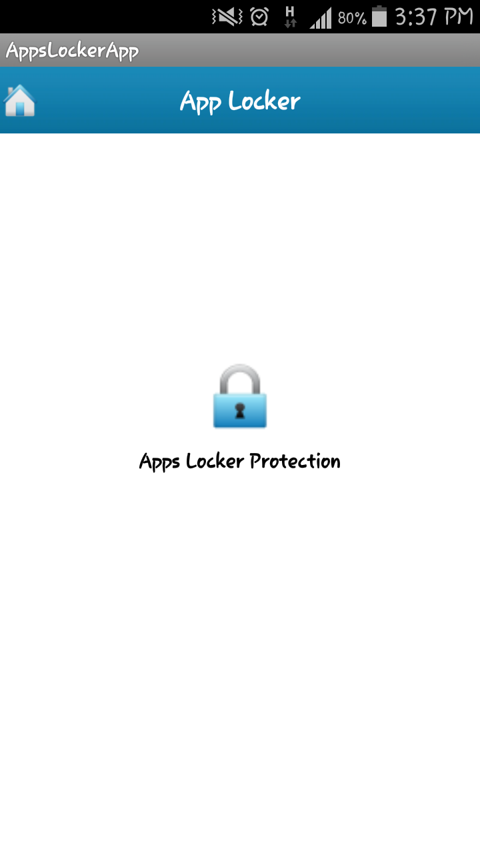

**Main screen for app locker**

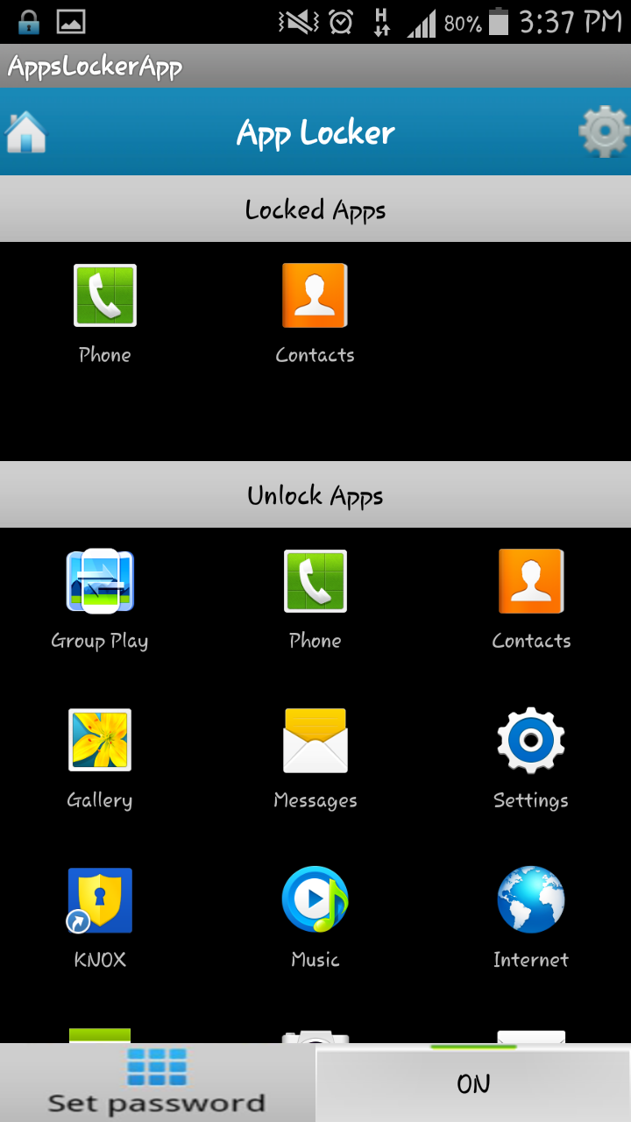

**Selection of apps to be locked**

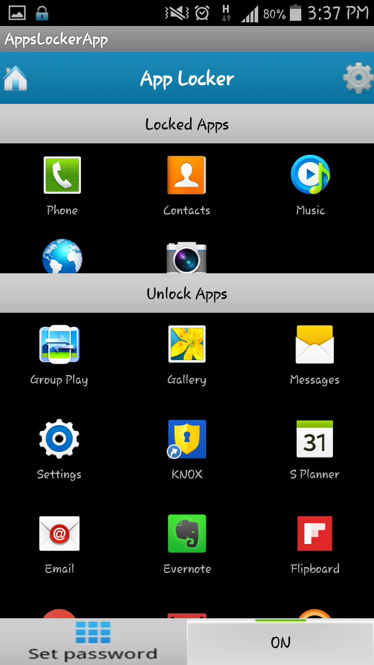

**Selection of apps to be locked**

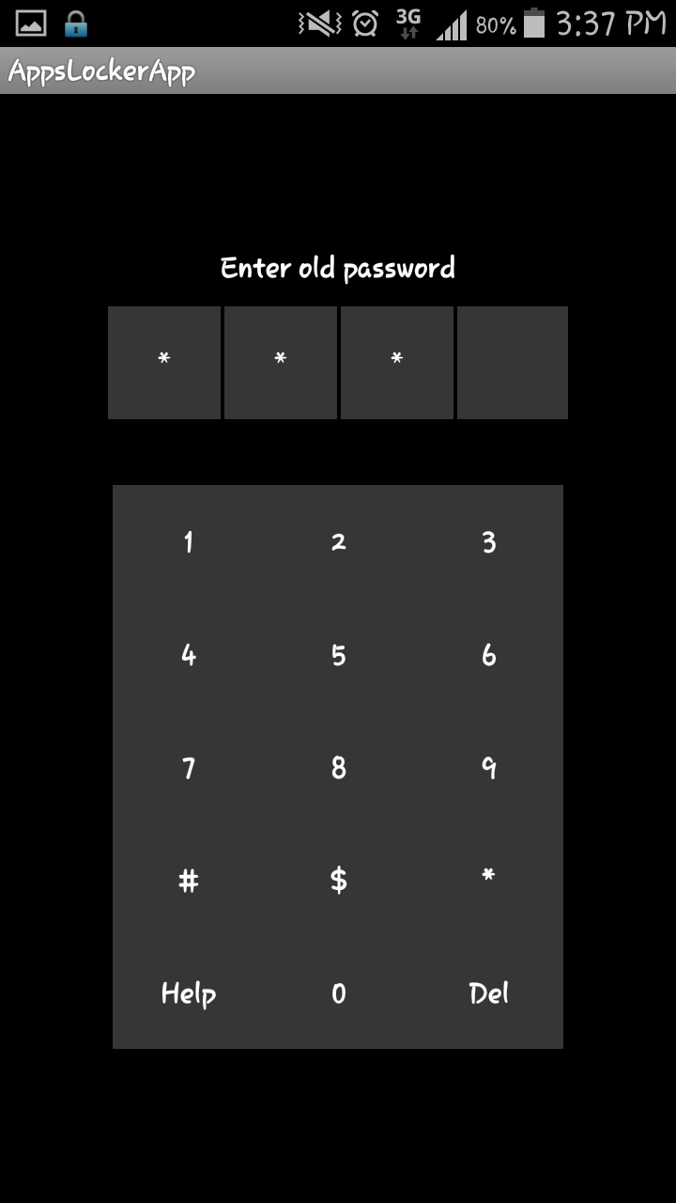

**Changing password: (i) Entering old password for security**

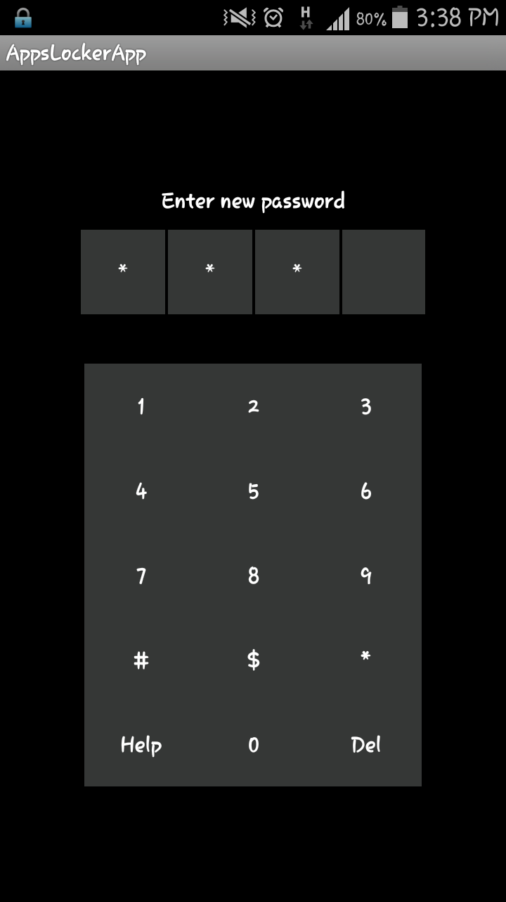

**Changing password: (ii) Entering new password for security**

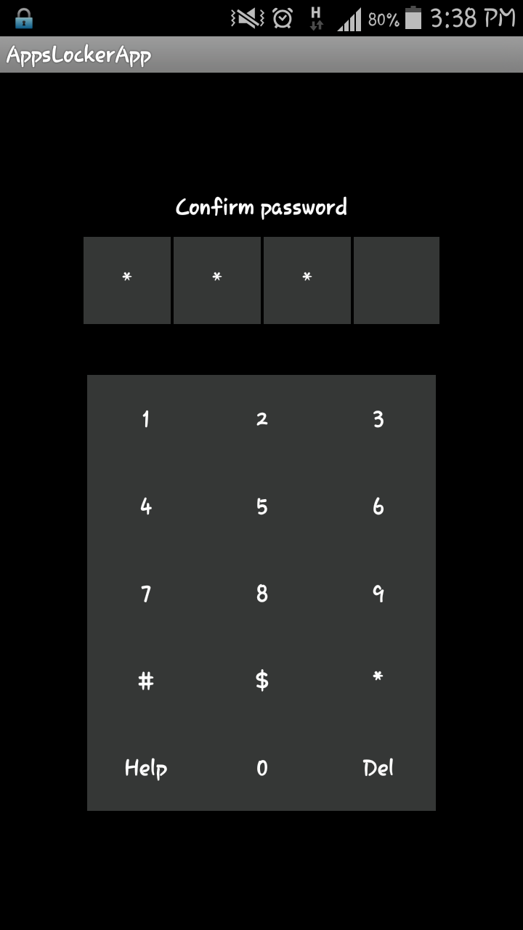

**Changing password: (iii) Confirming the new password**

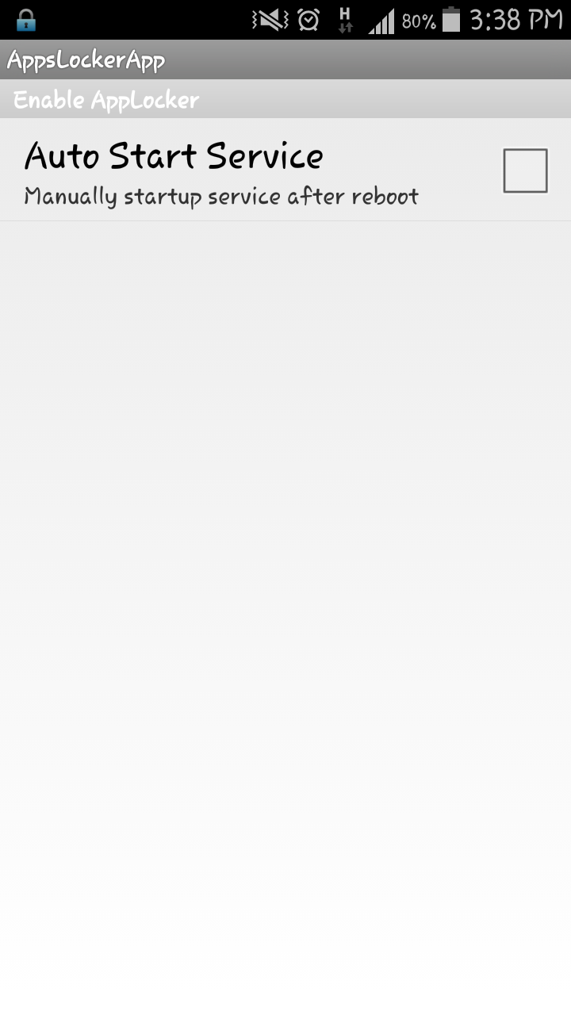

**Auto start service**

**CONCLUSION AND FUTURE SCOPE**

An app lock is necessary for most users since every android user has files and apps he wishes to hide from his friends, family or colleges. Our app being advertisement free and safe provides such users with a protective film over their personal data. While android users who want to hide their data exist, our app will never fall short of users. Containing features of all major app locks in an ad free environment makes it less of an headache for users to keep exiting the ad. The resultant app may have no distinguishing feature from other apps present, but constant improvements and updates would pack it with features and also keep the app stable and tested. This would reduce all inconvinience to the end user whose satisfaction is of utmost importance.

Future scope in our app can be-

Facial recognition

Gesture driven unlocking

Fingerprint unlocking

**REFERENCES**

|  |  |
| --- | --- |
| [**https://www.youtube.com/user/ProgrammingKnowledge/videos**](https://www.youtube.com/user/ProgrammingKnowledge/videos) | **04/02/16-16/04/16** |
| [**http://developer.android.com/reference/javax/xml/parsers/SAXParser.html**](http://developer.android.com/reference/javax/xml/parsers/SAXParser.html) | **10/03/16-16/04/16** |
| [**http://www.tutorialspoint.com/android/android_sqlite_database.htm**](http://www.tutorialspoint.com/android/android_sqlite_database.htm) | **02/03/16-16/04/16** |